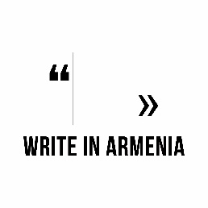 | 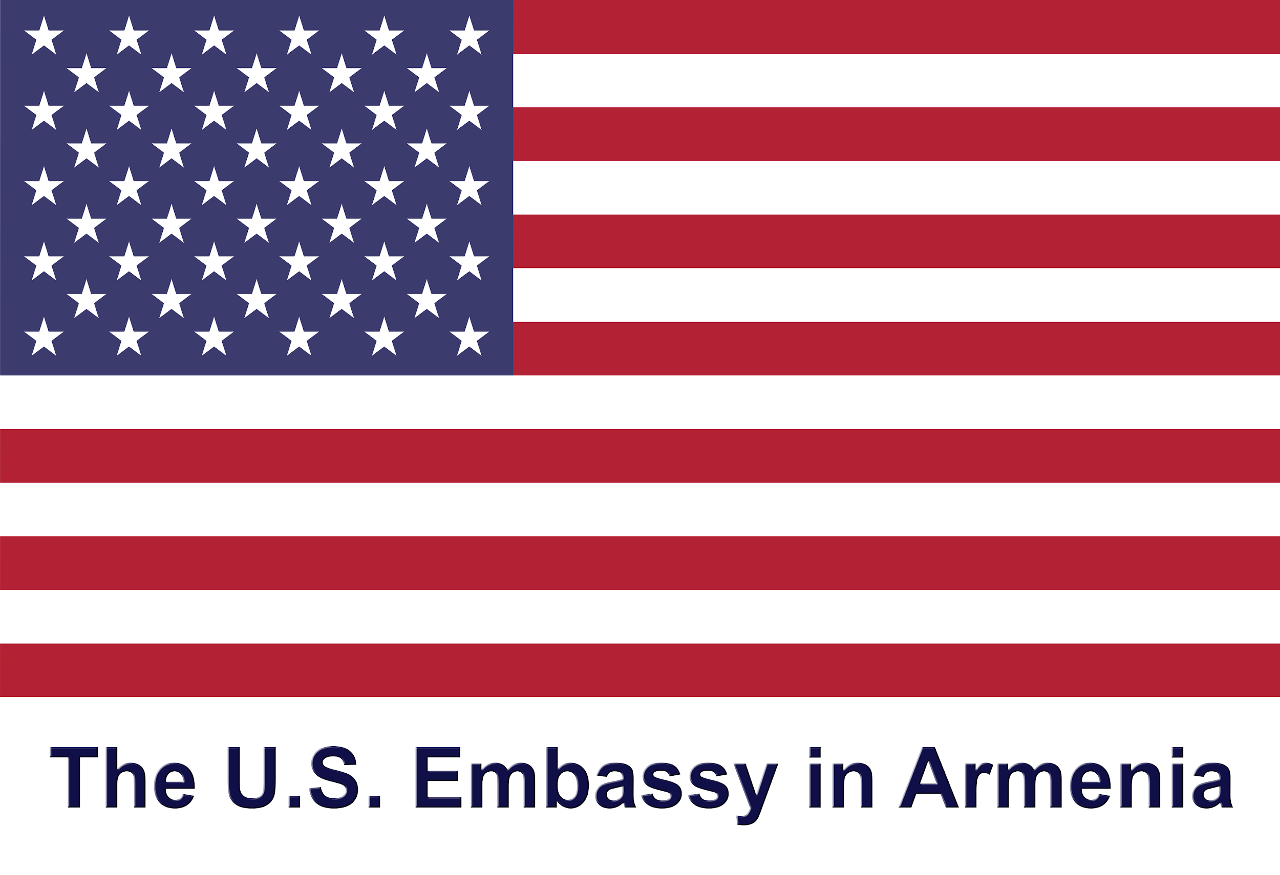 | 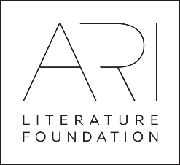
Application form

Applicant Information
Full Name:
 | Last | First
Date of birth:

Gender: | Male ☐ | Female ☐

Address:
 | Street Address |  |  |  | Apartment/Unit #
 | City |  |  | ZIP Code | Country
Phone: |  | Email

Education
Institution:
Specialization:

From: |  | To: |  | Did you graduate? | YES  ☐ | NO  ☐ | Degree:

Current Employment, if any
Company/ Organization:
Position:

Blogs, websites, social media pages
You blog or website link:
Facebook page link:
Twitter page link:

Language skills

 | Fluent | Functional | Fair | Weak
English | ☐ | ☐ | ☐ | ☐
Other please add | ☐ | ☐ | ☐ | ☐
Other please add

Your writing
Current focus or theme in writing:
Preferred writing style or form:
Publications, if any
Where did you learn about the program

Please submit this application, and the following documents:
- a cover letter explaining your interest in participating (in English),
- your resume or CV (in English),
- a writing sample in your native language,
- and a writing sample (in English),
to info@ariliterature.org and info@gpba.ge by September 30, 2018.
Other notes:
- All applicants will be considered for the program without discrimination of race, color, religion, sex, sexual orientation, gender identity, national origin, or disability status.
- Please note that you will be placed in a room with a roommate. (Only same gender) roommates will be chosen by lottery drawing.
- If you have any special needs, physical restrictions, food restrictions, seasonal or other allergies or other conditions that program staff should be aware of please describe in the space below:

Project partners:
